MERG West of Scotland Area Group
MERG Home page | Area Groups | More on our Knowledgebase | Group Members Page

West of Scotland AG website

Email
To contact us use, Contact MERG Please indicate WOSAG in your message
For MERG members, you might also like to look at our area group forum.

Who are the leaders of the group?
M1853 Davy Dick Group Leader
M4589 Bob Young Deputy Group Leader
M5195 George Parkinson Deputy Group Leader

Meetings
We see ourselves as a mutual-assistance group, where members look to each other for advice, help and support. Our members range from having little electronic knowledge to being fairly advanced. Interested members co-operate on their specific interests – e.g. everything from soldering skills and kit building to 3D printing and PIC and Arduino programming. The group aims to cater for all levels of skill. There is no specific commitments required from those who join. Members can put in and take out as much as they wish. None of us know everything and we can all learn from each other in a more informal manner than through the MERG forums and email groups. Of course, you don't have to participate in the Area Group, but you might find that we have a lot to offer - and learn - from each other.
We were very active prior to Covid-19, with all-members meetings in Glasgow on Sundays and fortnightly drop-in sessions on alternate Friday afternoons. In addition, we ran a selection of training workshops on basic electronics, kit building, using oscilloscopes, layout planning software, etc.
Here is a typical members' session. 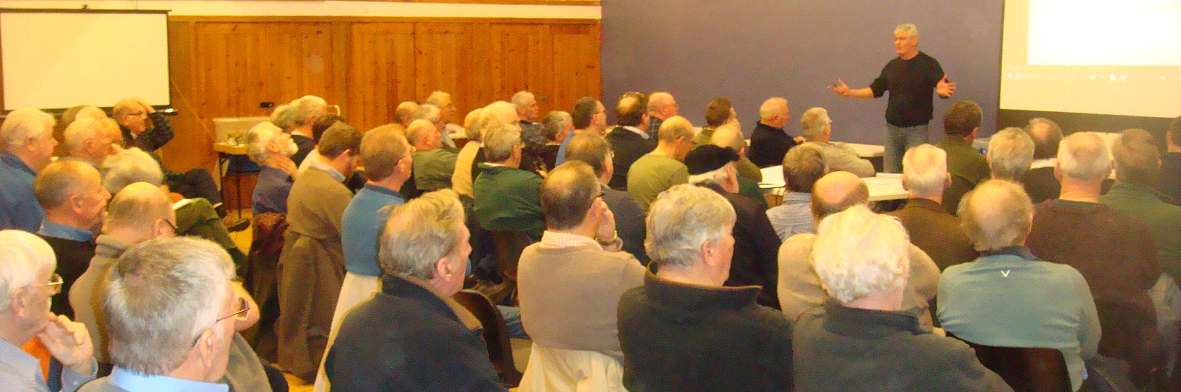
Previous discussions included power supplies and cutouts, layout wiring, fault finding methods, automation, motors, servos and steppers, making control panels, PCB design software, etc.

And the Next Meeting?
* Replace NN with the number of your area group - get from the AG admin page. Update the contact form title. *

Other Activities
Here is one of our demonstration layouts that show how to fit MERG kits to augment model railways. 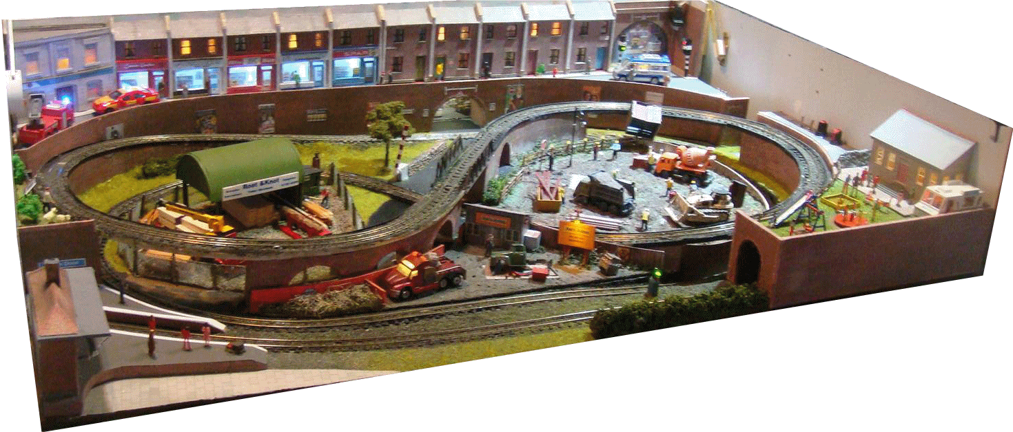
Here is our annual Open Day where we had demonstrations of building baseboards, track laying, point controllers, DCC, layout controls (CBUS and EzyBus), adding lighting, adding sound, Faller road systems, 3D printing, Arduino projects ……. 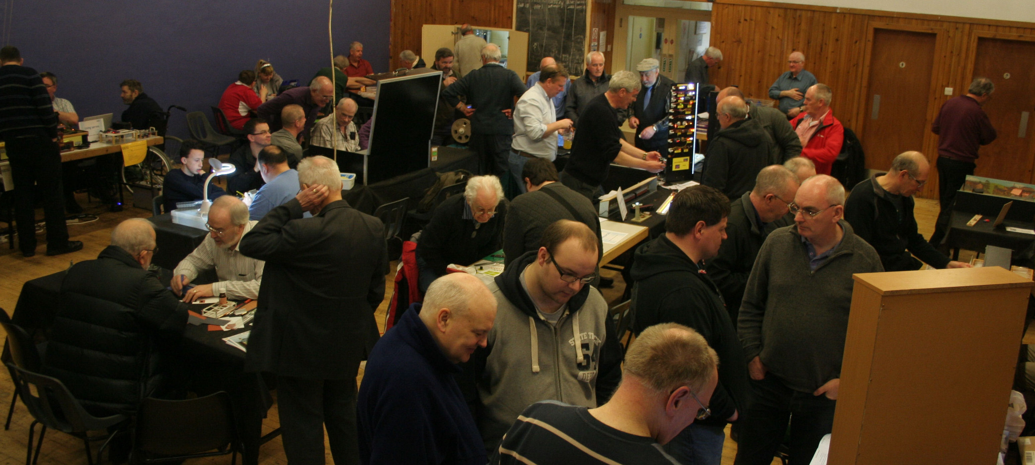
Here is a training workshop we ran on programming Arduinos. 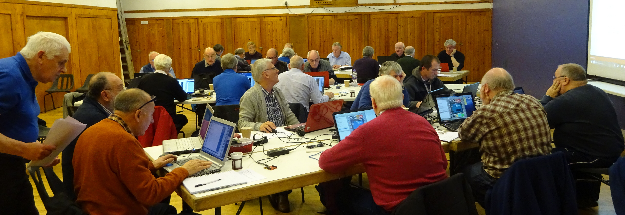
At the moment, we keep in touch with each other through our national and our local websites.
We also have weekly Zoom sessions on Sunday afternoons. Subjects covered included:
* Making latching reed switches for coach lighting
* Reusing parts salvaged from old printers and scanners
* Resin 3D printing
* Building animations
* Measuring voltage and current in DCC systems
MERG Home page | Area Groups | More on our Knowledgebase | Group Members Page

